***[Mechanical Engineering & CSE]***

|  |  |
| --- | --- |
| **Project Name** | **Autonomous Multiple Cycle Farming in Space** |
| Team Lead: | Courtney Cline |
| Team Member(s): | Dominic Allard, Philip Bernhard, Joshua Calhoun, Courtney Cline, Giampiero Corsbie, Timothy Frazier, Kali Jenson, Bryce Johnson, & Christopher Millsap |
| Faculty Advisor(s): | Dr. Elisabeth Kames, Mechanical Engineering & Dr. Philip Chan, Computer Science, Florida Institute of Technology |

Project Description:

With NASA gearing up for the Artemis program and space exploration expanding rapidly to accommodate life beyond Earth, there exists a need to grow food autonomously that can support humans reliably, without compromising valuable time, or energy, from other missions in space. Therefore, students across multiple disciplines joined forces to build an Autonomous Multiple Cycle Farming System (AMCF) that grows plants autonomously through robotic functions with limited human interaction for multiple cycles. A picture containing sitting, table, white

System Design: To make an autonomous system that seeds, grows, and harvests plants, three major systems are needed: water delivery, planting system, and base. In conjunction with these three systems, there will need to be a power supply, lighting, nutrients, and plumbing for support. Design is in accordance with SSP 52000-IDD-ERP NASA requirements on International Space Station.

One of the major challenges in this project was designing a way to autonomously control and configure the Farming chamber so that it would be able to grow various crop types. We created a new type of scheduler and configuration paradigm to meet these challenges. The Autonomous Multi-Cycle Farming system is ready to use as a proof of concept where the users can manually control, configure settings, and view diagnostic reports on the Farming Chamber.

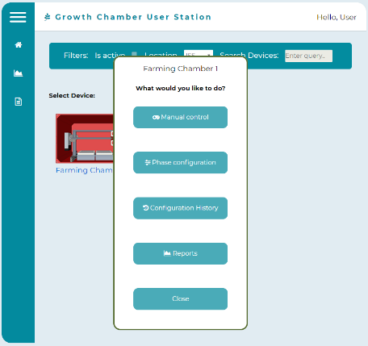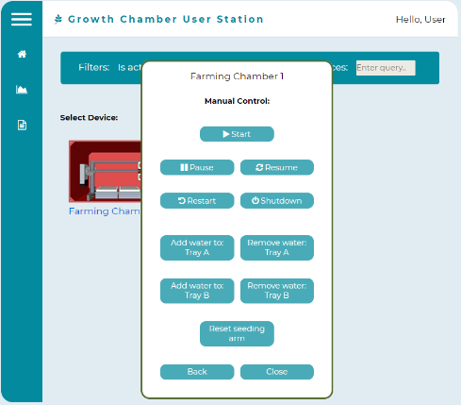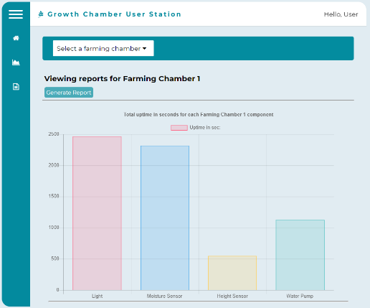

Future Plans: It is with great pleasure to announce that we have already submitted the Autonomous Multiple Cycle Farming System concept to two different NASA programs: “Technology Advancement Utilizing Suborbital Flight Opportunities ‘Tech Flights’,“ as well as “Student Payload Opportunity with Citizen Science (SPOCS)” at Johnson Space Center.